

WE BRING INTELLIGENCE TO LIFE

TO WHOMSOEVER IT MAY CONCERN

This is to certify that Mr. Raj Patel is working in our organization -Shrine Software Services Pvt.

Ltd. from 1st December 2019 to 31st December 2020 as Salesforce Developer.

For 13 months of working for us, he demonstrated as a diligent and truthful person. His interpersonal skills are outstanding and he has been very helpful. He has been very professional during the tenure here. We wish him all the best in future endeavors.

Thanks, and Regards,

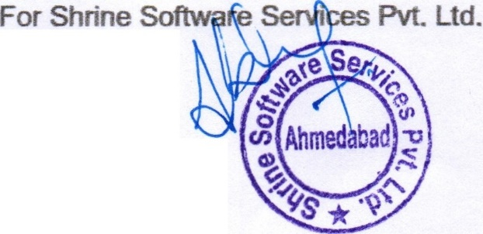

Abhay Mithani Human Resource



r.;-... hr@shrinesoft.com

© +91 960 199 9798

*i..::::J* www.shrinesoft.com

*[;;\* A-1006, Empire Business Hub, Science City Road,

*\::..J* Sola,Ahmedabad ·380060. Gujarat. INDIA